**456/1**

**MATHEMATICS**

**PAPER 1**

**NOV/DEC 2023**

**ST LUCIA HIGH SCHOOL**

**END OF YEAR EXAMINATION 2023**

**S.1 MATHEMATICS**

**PAPER 1**

**TIME: 2 HOURS**

**INSTRUCTIONS TO LEARNERS**

**Answer all questions in Section A and any two in Section B.**

**Each question in Section A carries four marks and each question in Section B carries 20 marks.**

**Show all the working and necessary explanation on the answer sheet provided.**

**SECTION A (40 MARKS)**

**(SHORT RESPONSE QUESTIONS)**

1. At a park which operates from 6:00a.m to 6:00p.m, a taxi leaves every 30 minutes while a bus leaves after every 40 minutes. Given that both the first taxi and first bus left the park together at 6:00a.m,
2. What would be the next time the taxi and the bus will leave together again? (03 scores)
3. How many times will they leave the park together in a day? (01 score)
4. A ship carrying merchandise from port A drops them at port B, which is 40km at a bearing of 1200 from port A.
5. Using a scale of 1cm to represent 5km, construct an accurate diagram for the journey of the ship. (03 scores)
6. State the bearing of port A from port B. (01 score)
7. A student was given four cards containing the vertices of a regular polygon and along the way one card got lost. The cards remaining A (1, 5), B (4, 1) and C (1, -3). Plot points A, B and C on a Cartesian plane and locate the position of card D which would make ABCD a kite. (04 scores)
8. The refugees who migrated from Eastern Congo due to ADFs are hit by famine in Northern Uganda. The government of Uganda decides to give each member in the house a potato to reduce famine. The government usually gives potatoes in an equal number of heaps of six potatoes each.

There are 12 households in the refugee camp, whose members 2, 3, 4, 5, 3, 7, 9, 8, 11, 12, 8, 10.

Task:

Help government to design a distribution plan for number of heaps of potatoes. (04 scores)

1. The diagram below shows Mr. Lumumba’s piece of land gazzetted for constructions.

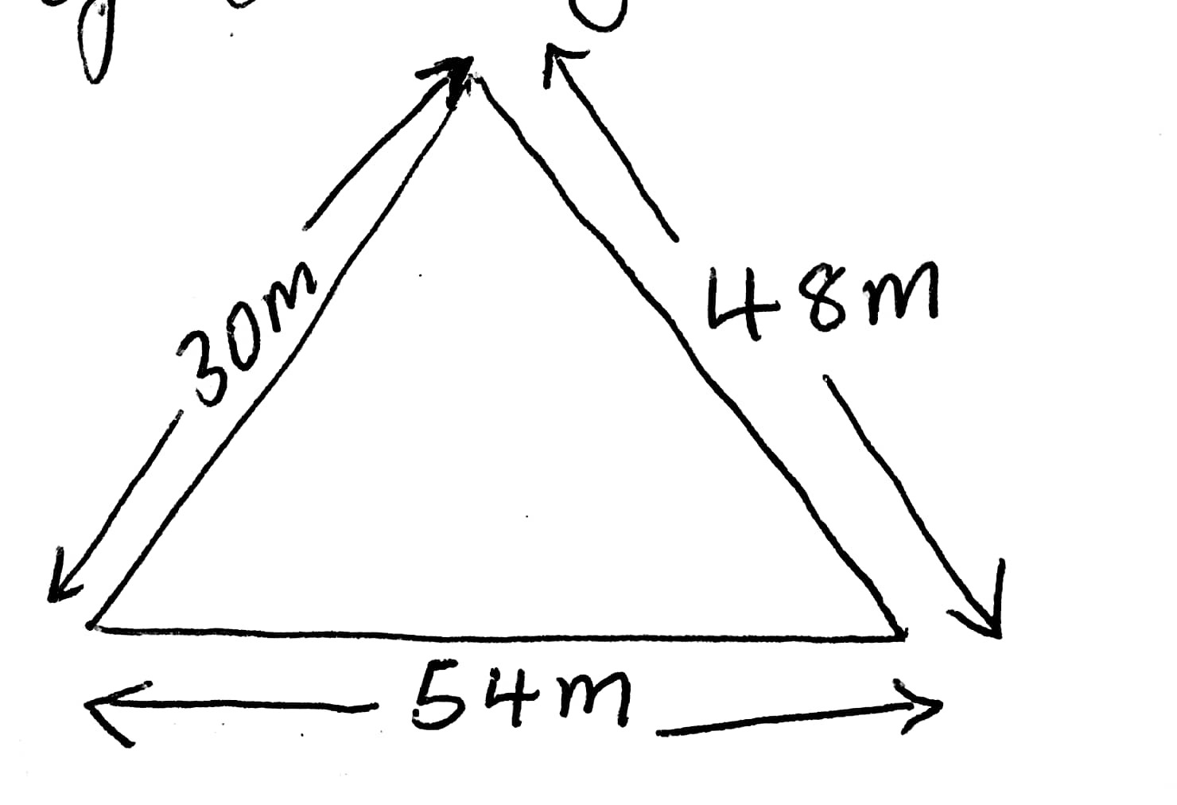

He received a donation of enough barbed wires and wishes to fence his land. He doesn’t have enough money to purchase the fencing poles which costs Shs. 5,000 each. As an agriculturalist, help Mr. Lumumba to come up with a budget estimate for the required number of fencing poles if the cost is to be as low as possible. (04 scores)

1. Jonathan is a business man located at Mpanga market. He discovered that the number of customers buying from his shop increases by four every week. As a sales promoter, he intends to give a free sweet to whoever buys from his shop during the 6th, 8th and 12th week. He wants to purchase the sweets early enough but he does not know how many of them he should buy for the promotion.

Support: There were only 3 customers in the first week.

Task:

Help Jonathan to establish the number of sweets he needs to purchase for the promotion.

1. Your teacher of mathematics travelling along a straight road realized that he passed a certain bodaboda stage at point (-5, 7) and the school at point (3, 13). Form an equation of the straight road connecting the stage to the school. (04 scores)
2. (a) Mulindwa had 21.4 coins. After coming back from the toilet he, realized that some coins had fallen in to the toilet and he ended up with only 0.82 coins. How many coins were lost? (02 scores)

(b) Basiku is distributing 60 exercise books to her four children. Muyiyi got 12%, Nasike got 15%, Wamono got 33% and Wenene got the remainder.

Express the percentage of exercise books Wenen got as a fraction in it’s simplest form. (02 scores)

1. The diagram below shows the dimensions of a graph paper of perimeter 46cm.

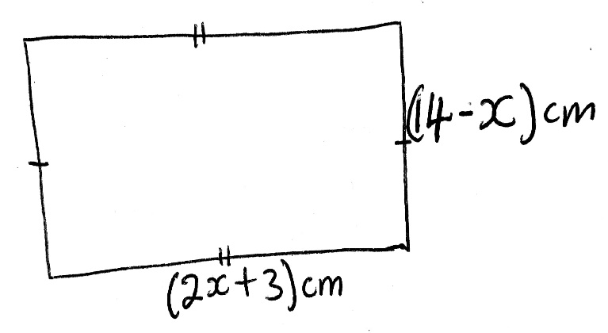

Determine the value of x. Hence find the area of the graph paper. (04 sores)

1. Using a number line identify the directed numbers of movements made by each of these students.

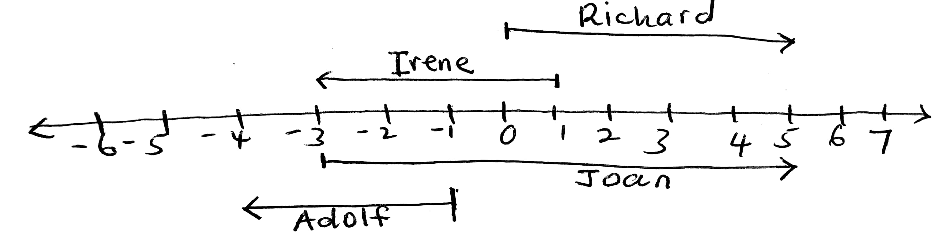

**SECTION B (40 MARKS)**

1. **Attempt only two questions**

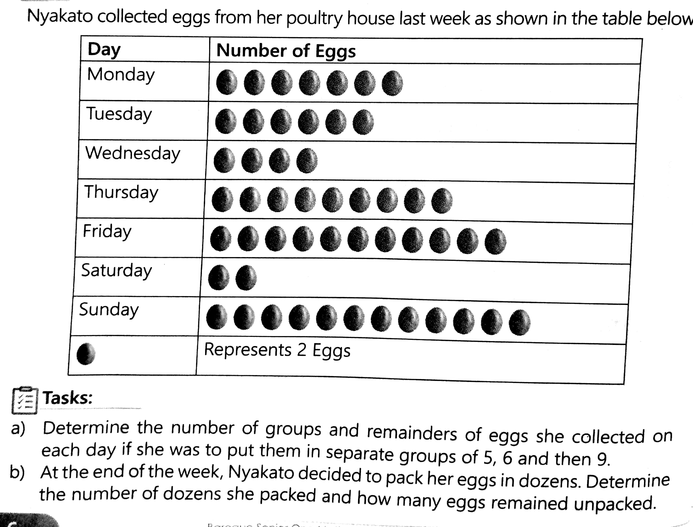

1. A canteen operator of your school asked some students on the items they like eating so that he could stock his canteen with the items they like. He found out that 8 students liked chapat, 12 liked lindazi, 20 students liked sweets, 10 liked Biscuits, 6 liked lato milk and 4 students like tumbuya. He ended up getting confused because the data was disorganized.

Resources

Knowledge of tally charts, bar graphs and pie charts.

Task.

Help the canteen operator to understand these figures clearly. If you were to do business at the above school canteen, which item would you deal in? Give a reason for your answer. (20 scores)

1. Your neighbor has a triangular piece of land with labels ABC with measurements. He wishes to construct a circular poultry store that just fits inside his piece of land touches all the three boundaries of his land.

Support

Length ABC = 750 and BAC = 450.

Resources

* Knowledge of measuring length and angles.
* Knowledge of drawing constructing perpendiculars, angle bisectors and parallel lines.
* Knowledge of selecting a suitable scale for construction.

Task

As a knowledge member of a community and a professional engineer, help your neighbor to come up with accurate foundation for the construction of the circular poultry store. What would be the radius and the area of the foundation? (20 scores)

1. Study and interpret the timetable below for a bus
2. Travelling from Kampala to Mbale.

|  |  |  |
| --- | --- | --- |
| Stage | Arrival time | Departure time |
| Kampala |  | 7:30a.m |
| Jinja | 8:30a.m | 9:00a.m |
| Iganga | 9:45a.m | 10:00a.m |
| Mbale | 11:15a.m |  |

1. How long did the bus take in Jinja?
2. Write the departure time from Kampala in the 24 hour clock?
3. How long did the bus take to move from Kampala to Mbale?
4. You have come to the end of the year 2023 and now you are going home for holidays, you are expected to spend the holiday time meaningfully.

Support

Duration of holiday is 2 months

Suggested activities at home include; house chores, community service, physical fitness and personal study.

Resources

Knowledge of using units of time

Knowledge of making timetable

Task

Describe to your head teacher how you are planning to spend your holiday.

**END**

**WISHING YOU A MERRY XMASS AND A PROSPEROUS NEW YEAR 2024.**